EMG/Nerve Conduction Study Handout

Dublin Physical Medicine

6905 Hospital Drive, Suite 120

Dublin, OH 43016

Phone: (614) 792-3767
FAX: (614) 792-3768
www.dublinphysmed.com

Todd E. Kerner, M.D./Ph.D.

- Nerve Conduction Study: This study enables us to test your nerves and assess their overall health. The physician places measuring electrodes (similar to EKG electrodes) over the nerve. Then, he uses a handheld stimulator to introduce a small pulse of electricity lasting less than 1/1000th of second to several spots over the nerve. By analyzing the recorded impulses, the physician basically “maps” the nerve of interest. Although the pulse feels “odd” (like static electricity shock in the wintertime), most patients agree that it does not hurt. There are no known long-term harmful side effects. This device is safe to use with patients with pacemakers. Most skin creams will interfere with this test, so they must be thoroughly removed beforehand with soap and water.
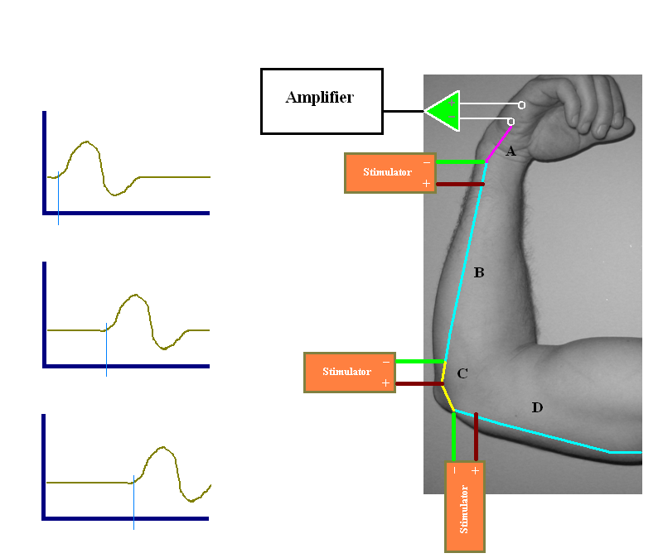

- EMG: This stands from electromyography. During this part of the test, the physician is literally watching and listening to muscle fibers firing within your body. From this test, he can assess the health of both the muscles and the nerves innervating them. The physician will insert one very thin pin (similar to an acupuncture needle) in several muscles (controlled by the nerves and spinal root levels of interest) to best diagnose your problem. During this part, no electricity is delivered nor is anything injected into you via the pin electrode. To minimize discomfort, relax as much as possible and only contract the tested muscle when asked to do so. Again, there are no serious, known long-term side effects from this part of the test. Some patients may temporarily experience minor bruising, a drop of blood, or aching in the areas tested.

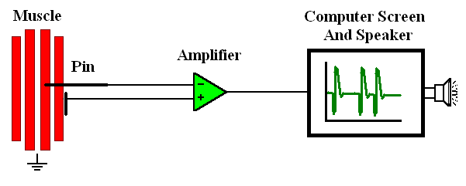
If you are needle phobic or already have extreme pain where we will perform the test, please call our office and LET US KNOW AHEAD OF TIME. WE MAY CHOOSE TO SEDATE YOU during the procedure. If you are sedated during the procedure, you will need a driver to bring you back home.

If any of the below conditions apply to you, please bring them to physician’s attention BEFORE we start the test:
▪ Active infection (including fever within past 24 hrs)
▪ Pregnancy (currently)
▪ Hypersensitivity reaction to tape or latex
▪ Phobia of needles
▪ Implanted devices (artificial joints, pumps, hardware, pacemaker, etc.)
▪ Moisturizers, oils, lotions, creams, ointments, or any topical medications anywhere on my skin

If you wear comfortable, loose fitting clothing (such as sweatpants, shorts, sleeveless shirts) , we may be able to avoid having you change into a gown during the exam and save you time during the visit.

